Debugging Angular Applications with Chrome DevTools
Chrome DevTools is your primary runtime debugger — used to inspect what’s happening in the browser.
🧠 What You Can Debug
- Component rendering issues
- Inspect DOM
- Track API calls (HttpClient)
- Change detection problems
- DOM / CSS issues
- Performance bottlenecks
🛠️ Key DevTools Tabs (Angular Context)
1. Elements Tab (DOM Inspection)
Use it to:
- Inspect HTML rendered by Angular
- Check applied CSS styles
- Debug structural directives (*ngIf, *ngFor)
👉 Example:
If your *ngIf is not showing:
<div *ngIf="isVisible">Hello</div>
Check:
- Is the element present?
- Is it removed from DOM or hidden?
2. Console Tab (Logs & Errors)
- Displays runtime errors
- Useful for quick debugging
ngOnInit() {
console.log('Data:', this.data);
}
👉 Common Angular errors:
- Cannot read property of undefined
3. Sources Tab (Breakpoints 🔥)
This is where real debugging happens.
👉 Steps:
- Open Sources
- Navigate to your .ts file (via source maps)
- Set breakpoint
- Refresh app
👉 Example:
getUsers() {
this.http.get('/api/users').subscribe(res => {
debugger; // breakpoint
this.users = res;
});
}
You can:
- Inspect variables
- Step into / over code
- Watch expressions
- 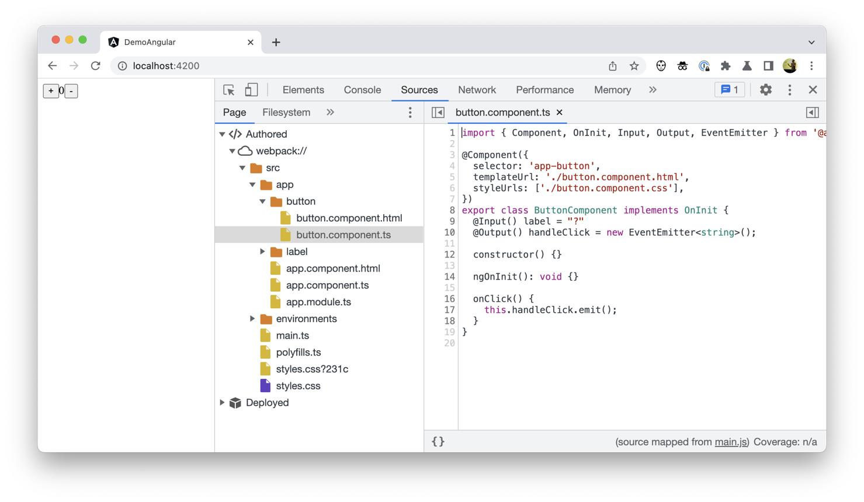
- 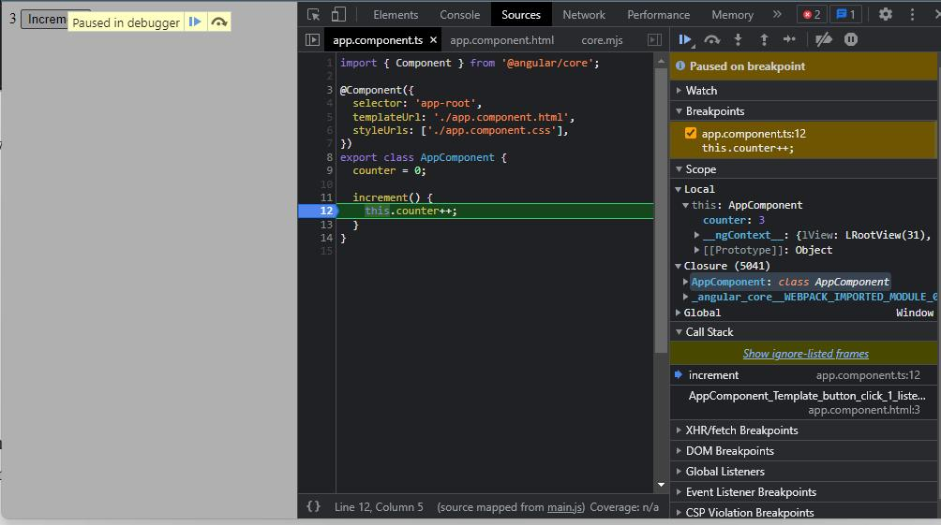

4. Network Tab (API Debugging)
Used for:
- Checking API requests
- Validating headers (Auth token)
- Inspecting response payload
👉 Example:
If API not working:
- Check Status Code (401 / 500)
- Check request headers:
Authorization: Bearer token
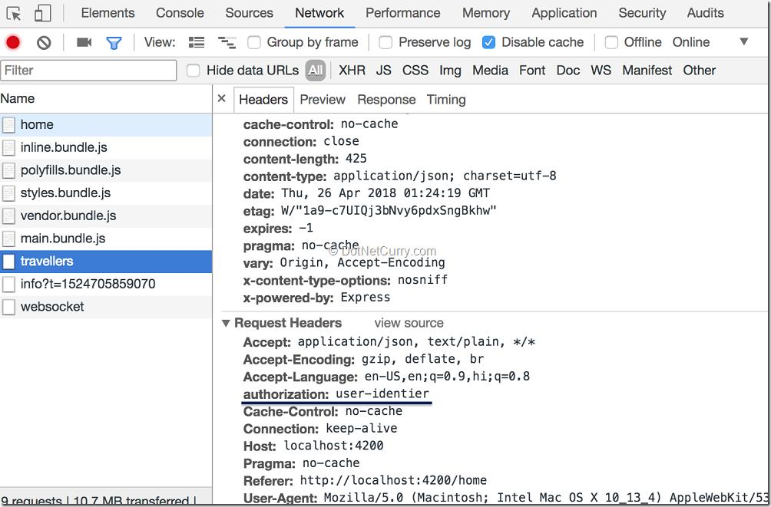

5. Angular DevTools (Extension)
Install from Chrome Store:
👉 Angular DevTools
Features:
- Component tree visualization
- Change detection tracking
- Performance profiling

⚠️ Common Issues You Can Catch
- Data not binding → Async delay / change detection
- API works but UI empty → wrong variable binding
- Token not passed → header issue
- Slow UI → excessive change detection

Step to Debugging Angular Applications with Chrome DevTools
⚙️ Step 1: Run your Angular app
ng serve
Open:
http://localhost:4200
🛠️ Step 2: Open DevTools
Shortcut:
F12 OR Ctrl + Shift + I
📌 Step 3: Debug using Console
Example Component
export class AppComponent {
title = 'Angular Debug';
ngOnInit() {
console.log('Component Loaded');
}
}
What to check:
- Console logs
- Errors (red ❌)
- Warnings (⚠️)
👉 Common issues:
- Undefined variables
- API failures
- Template binding errors

